

Advanced Web

Engineering

Documentation
Component 2

Name: Bandana Giri Id:- 77264976
Group - B

Larastore site

Larastore is an online marketplace that specializes in selling books, CDs, and games. It is an inventory-based site, which means that it keeps a physical stock of the items it sells and ships them to customers directly. The site features a wide selection of products, including both new and used items, and it is constantly updating its inventory to offer customers the latest and most popular titles. Customers can browse the site by books, cds and games.

Features of My project

- Provides functionality for managing products, known as CRUD (Create, Read, Update, Delete) functionality, which are exclusively available to the administrator.
- Includes a feature for new users to create an account and sign in.
- Includes alerts to notify the administrator of any changes made to products, such as when they are created, modified or removed.
- Includes validation on both the client-side as well as the server-side, ensuring the data entered is accurate.
- Responsive design using bootstrap and css
- When submitting the form, the user is given the appropriate error messages, if any.
- Use of http verbs and route management
- Uses of Gates and middleware for authorization

Extra Features

- Ability to reset the password if forgotten, through email verification using Mailtrap smtp
- Added pagination for the user to navigate through any page they want.

Screenshots of the project:-

- FrontEnd :-

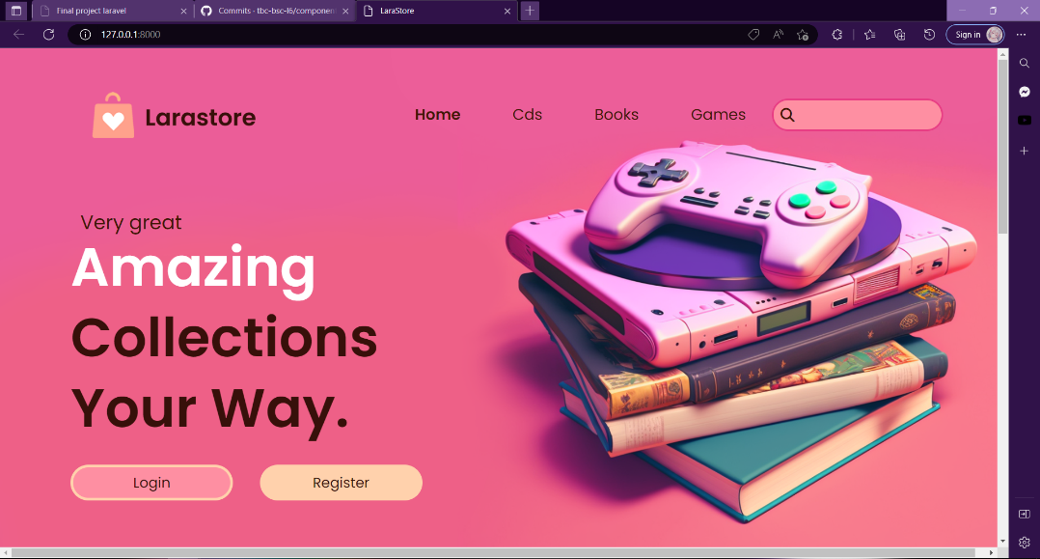

Body:

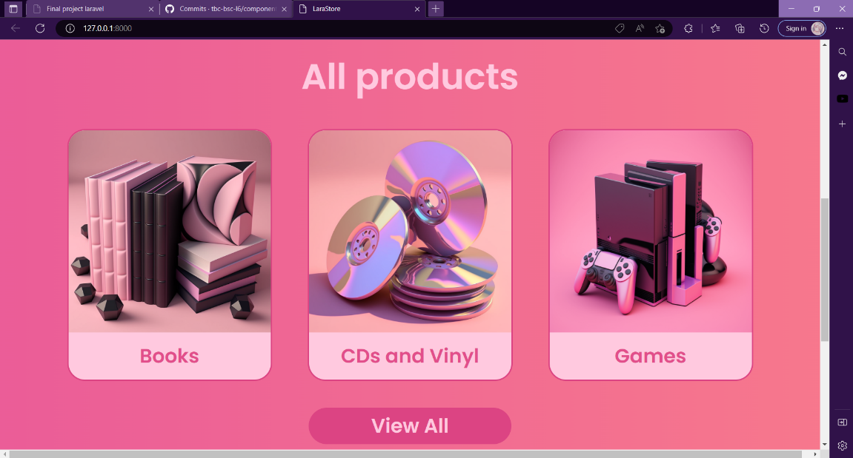

Footer:
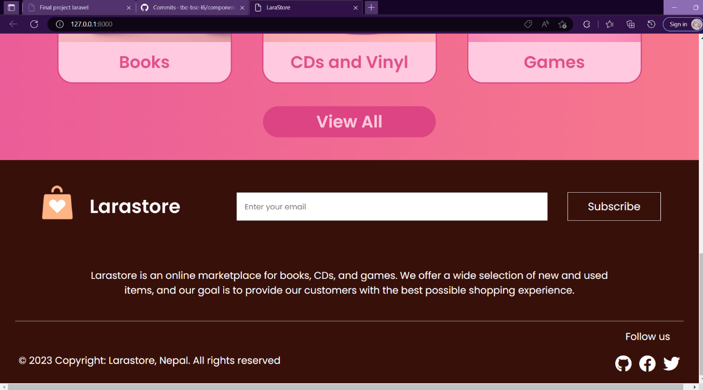

- Products shown in table format to the admin, where CRUD operations can be performed-
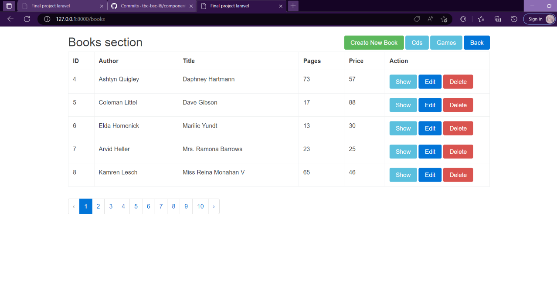

- Customer perspective:-
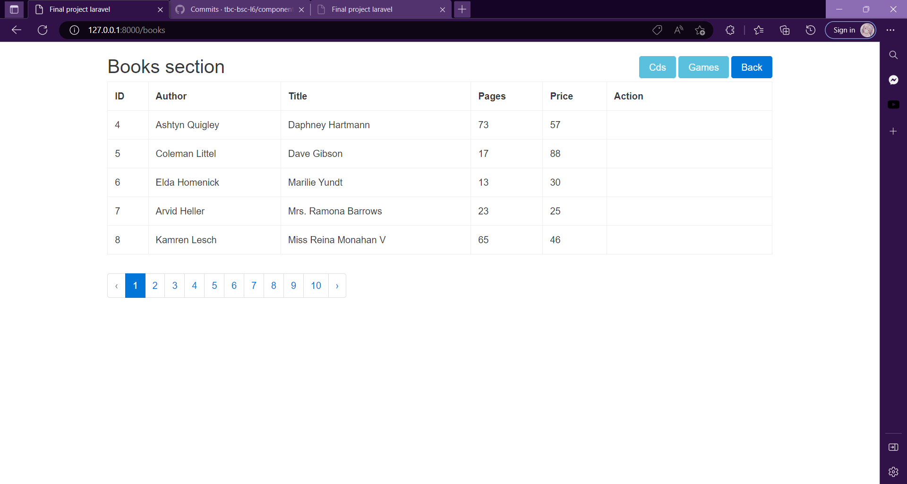

- Create Products Form-

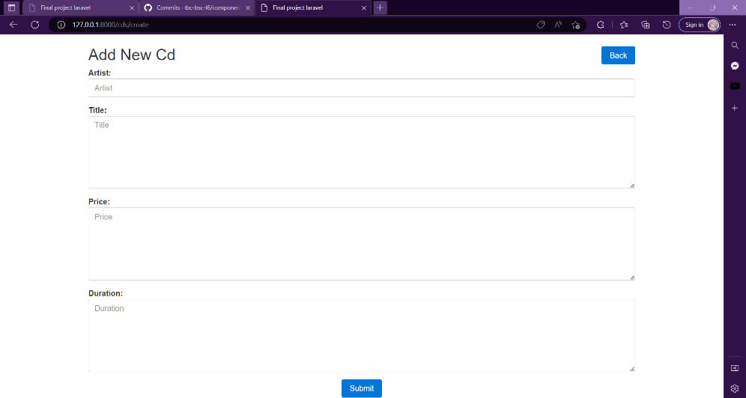

- Edit products form-
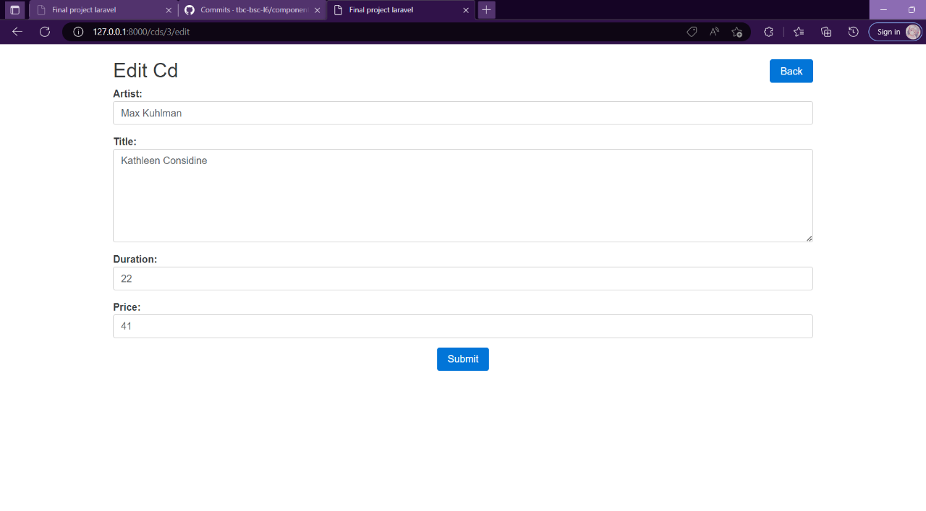

- Use of gate to define an admin-

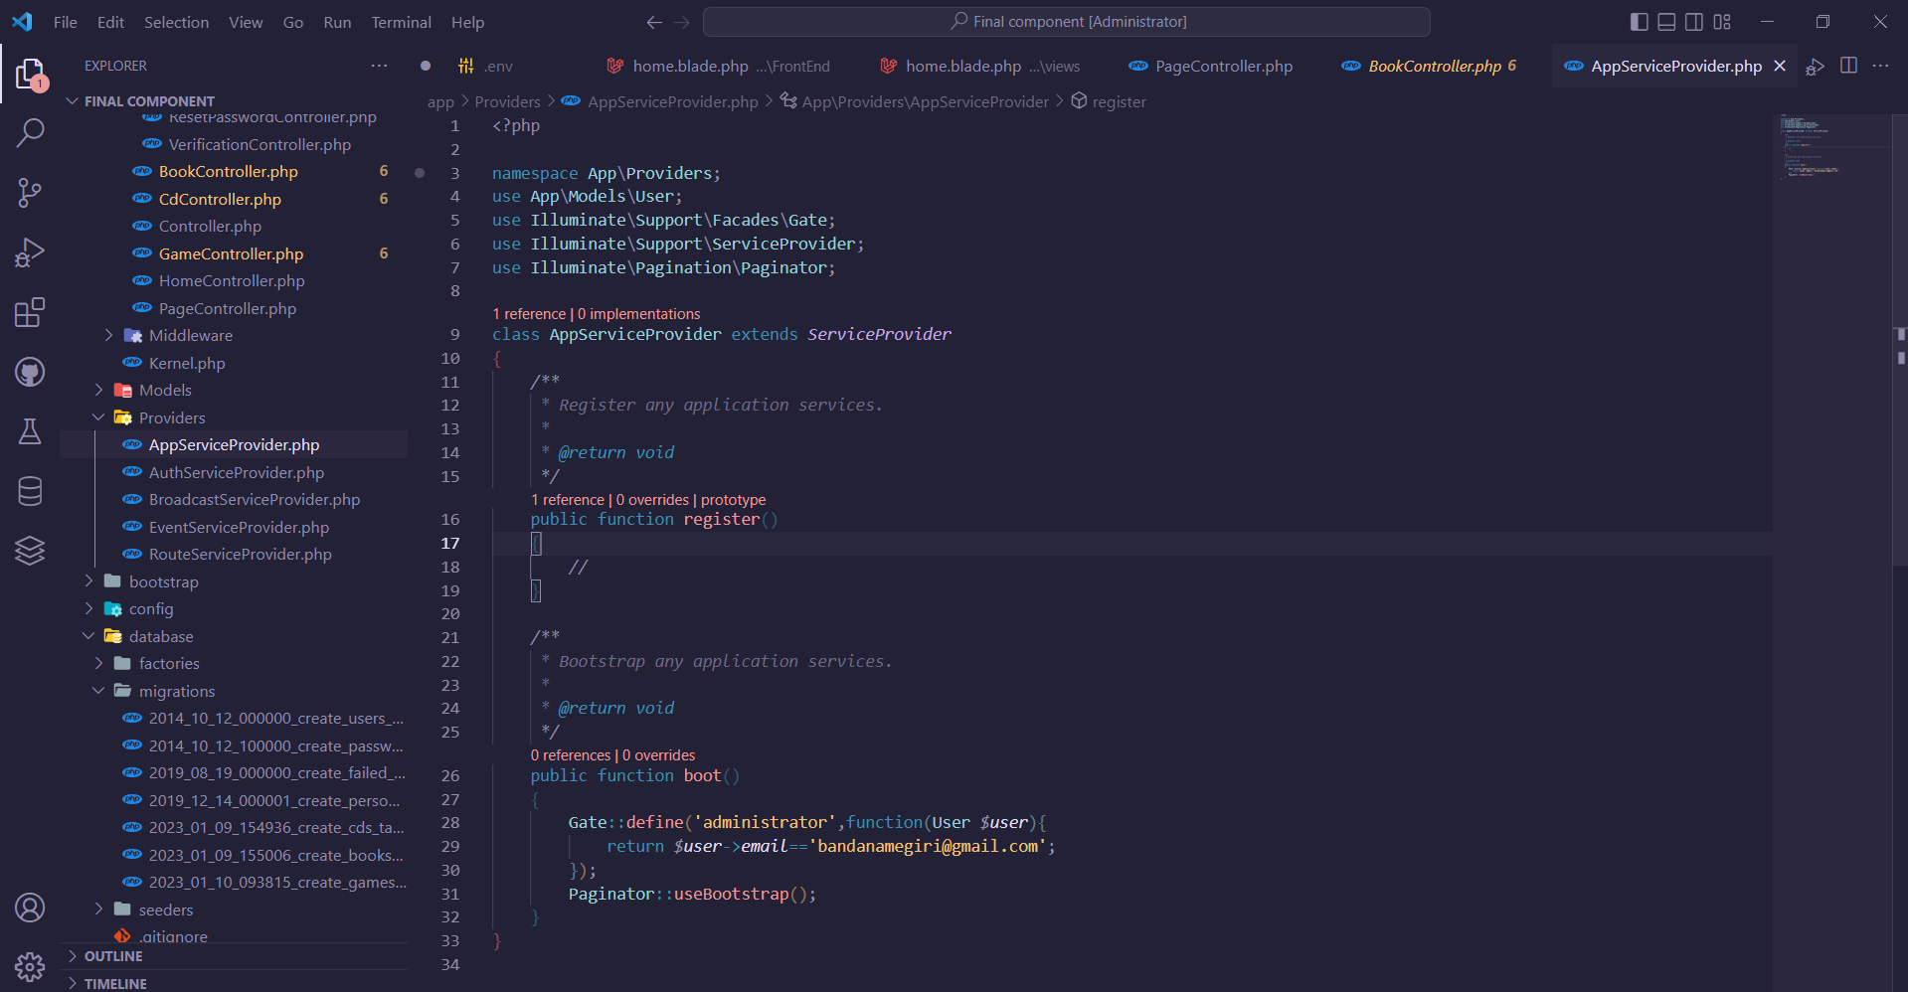

- Use of database seeder and factory to create dummy datas in the database tables-
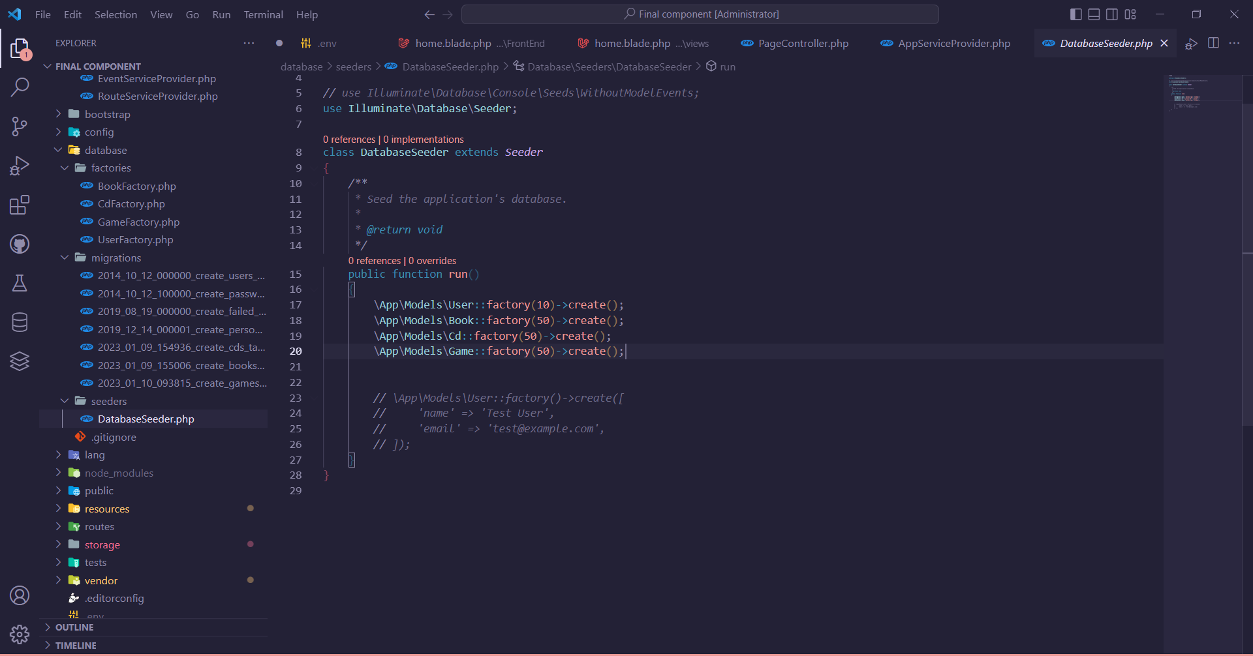

Video is committed on the github repository.

